## Setting up xampp

1. Download xampp at <https://www.apachefriends.org/download.html>. Select download button based on your OS.

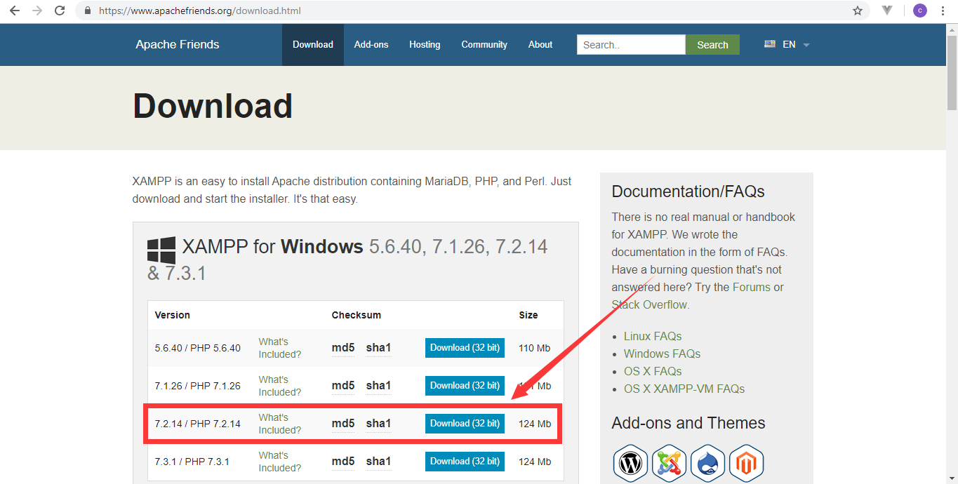

1. Follow the steps of installation at <https://www.wikihow.com/Install-XAMPP-for-Windows>.
2. Click the two buttons to start the apache and mysql then wait for it to start.

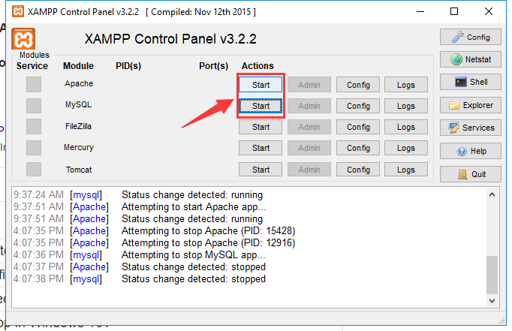

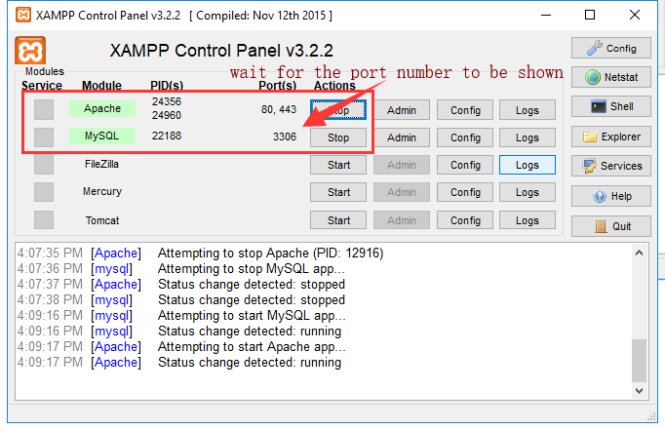

1. Open <http://localhost> in your browser to check if it is working.

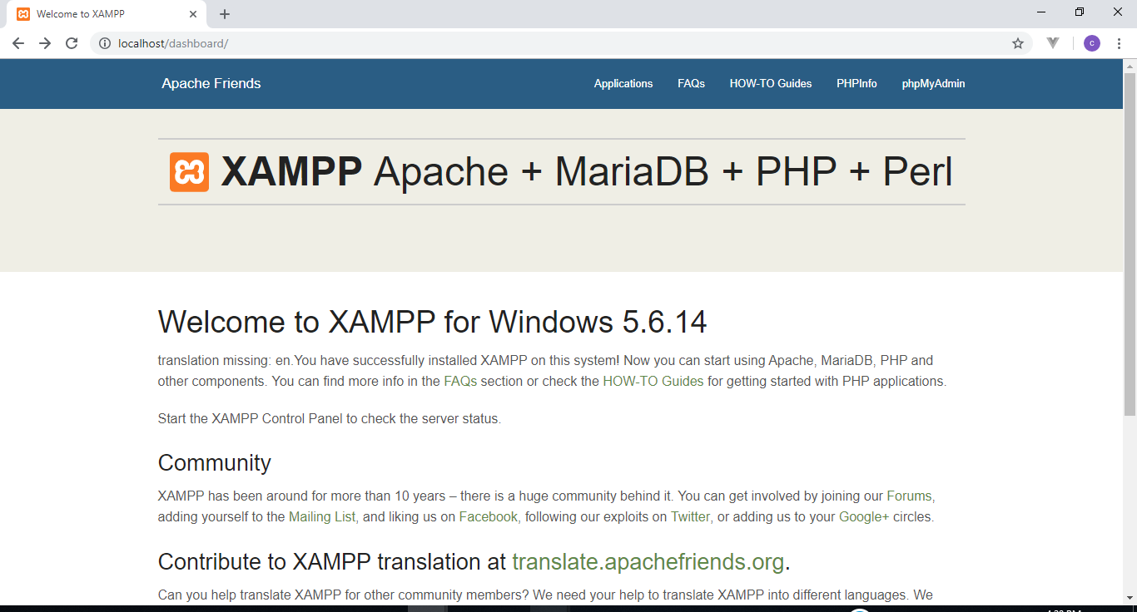

## Installing database of the system

1. Click phpMyAdmin to open the database page. It must redirect you to <http://localhost/phpmyadmin/>

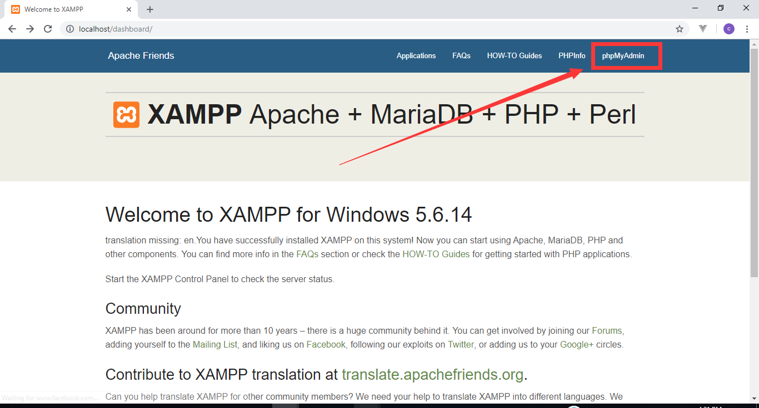

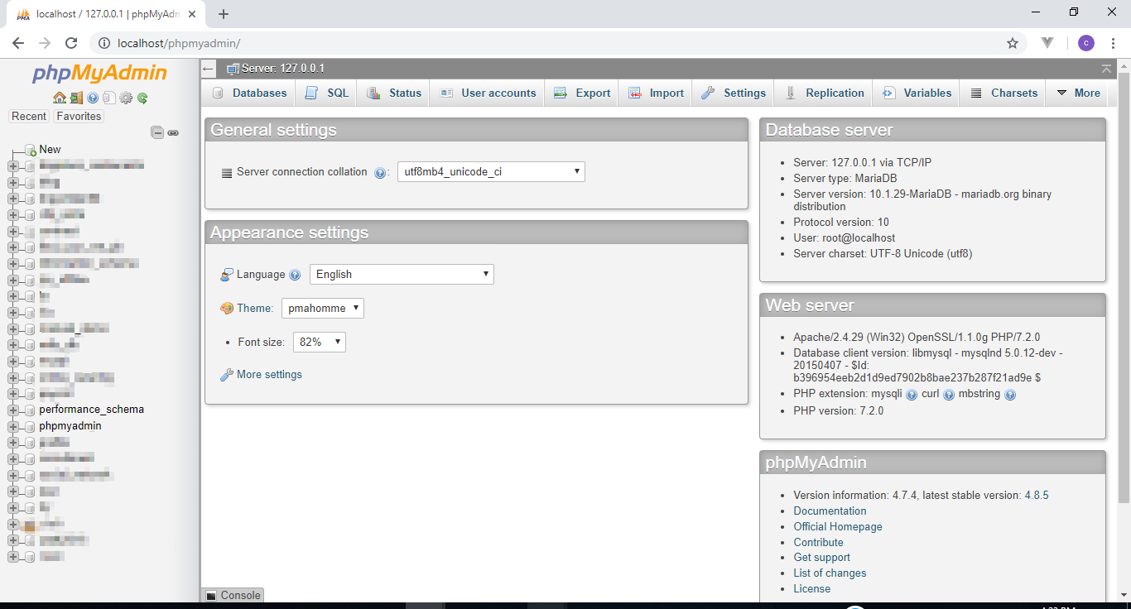

1. Click New to create new database

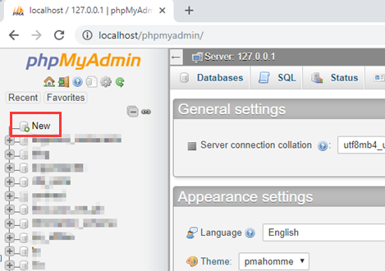

1. Enter `online_catering` at database name field then click create.

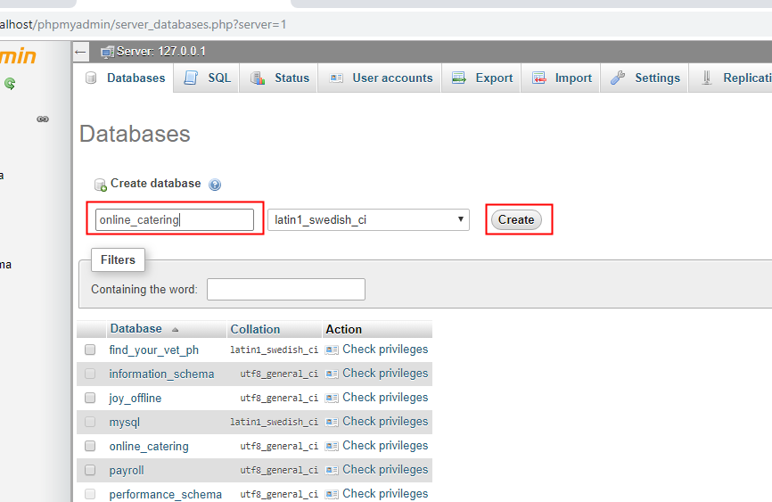

1. Click import

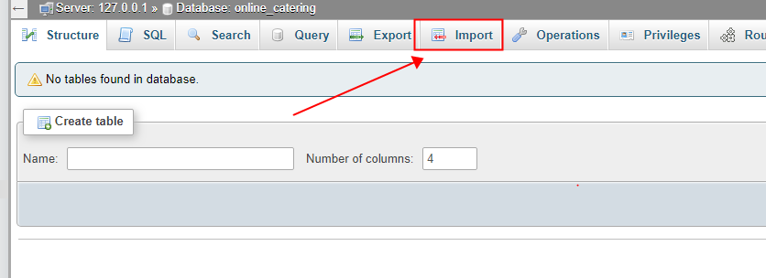

1. Click choose file then select the sql file of the database. The sql file is included in the zip file named `online_catering.sql`

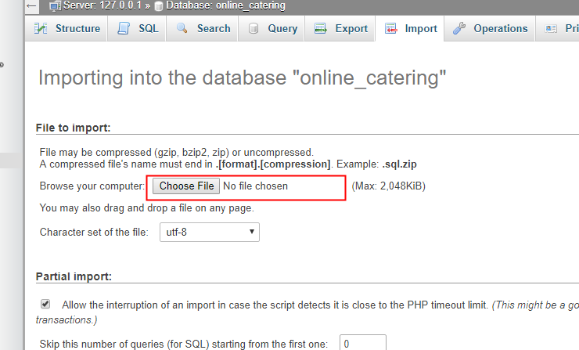

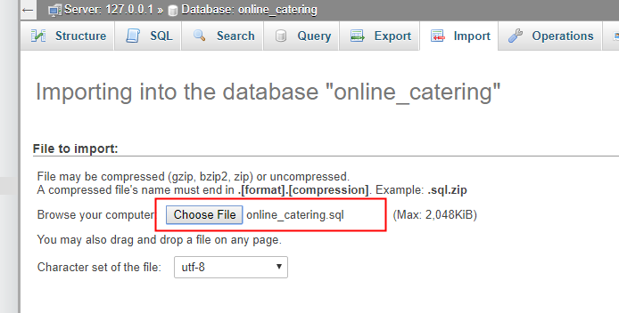

1. Leave everything in default. Click Go button then wait for the success notification.

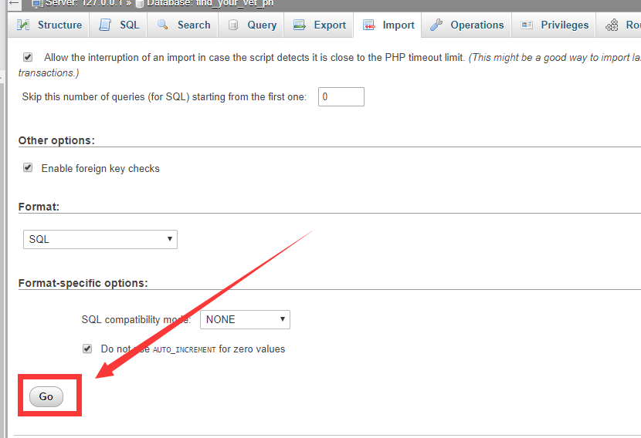

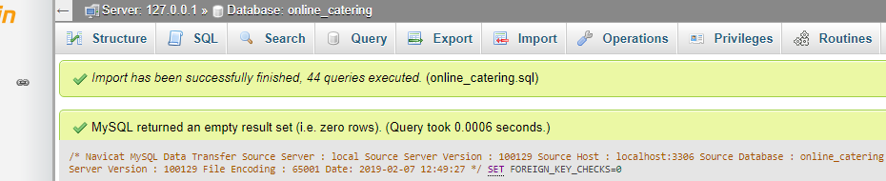

1. Click the database name to view the tables created.

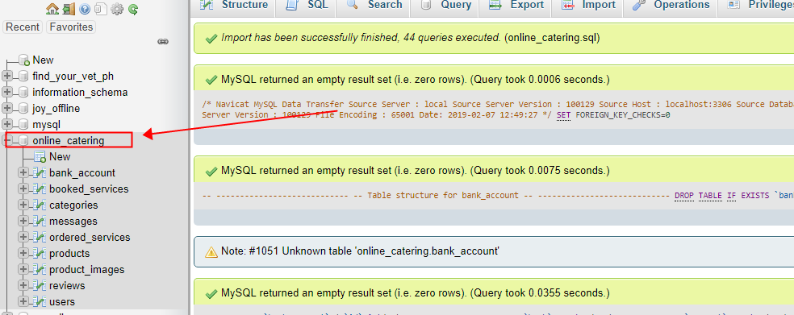

## Setting up system file

1. Open the folder where the xampp was installed

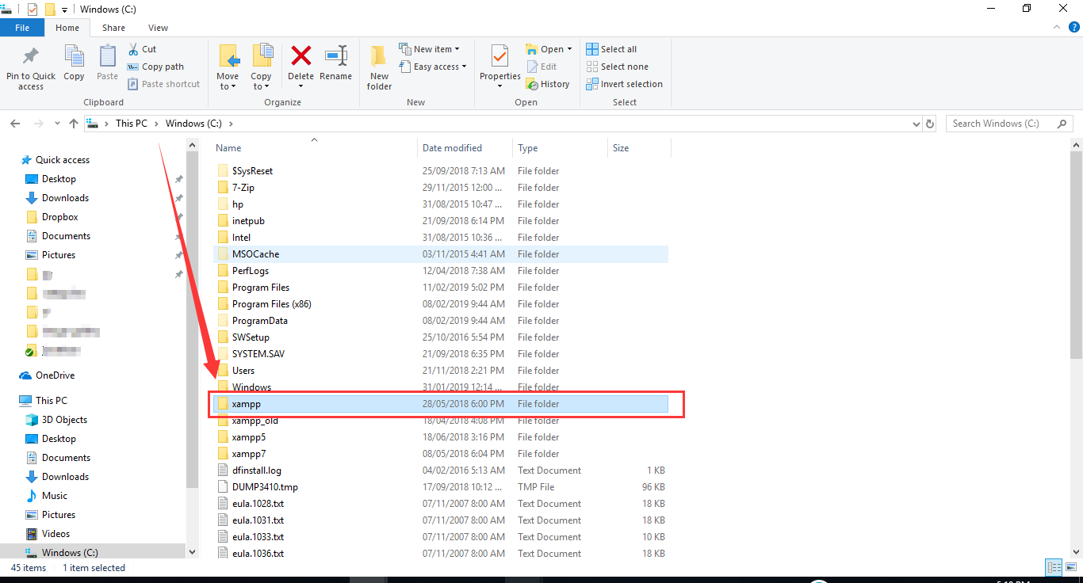

1. Open the folder xampp then find and open the htdocs folder. This folder is where the projects is saved.

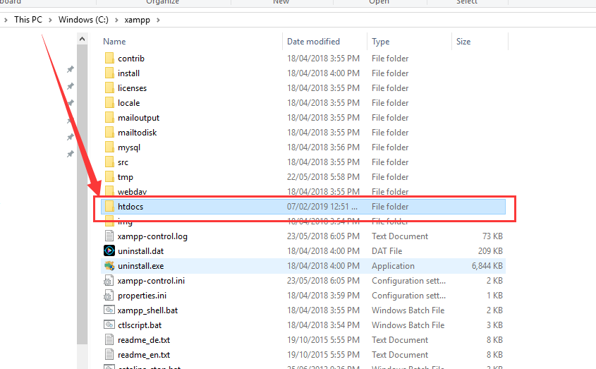

1. Copy and paste or extract the system file inside the htdocs folder.

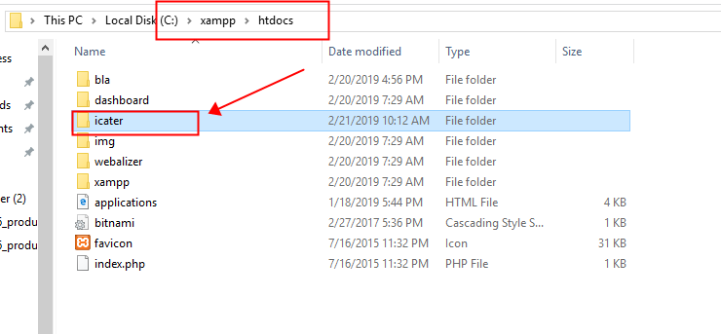

## Starting system locally

1. Open <http://localhost/icater/> in your browser.

